##### STUDENT INFORMATION SYSTEM

**A PROJECT REPORT**

###### ***Submitted by***

NAMAN GUPTA ( 21BCE11213 )

DEV MANGRANI ( 21BCE11444)

SHREYA PANDEY (21BCE11376)

##### BACHELOR OF TECHNOLOGY

*in*

**COMPUTER SCIENCE AND ENGINEERING**



**SCHOOL OF COMPUTING SCIENCE AND ENGINEERING**

**VIT BHOPAL UNIVERSITY**

**KOTHRIKALAN, SEHORE**

**MADHYA PRADESH - 466114**

DECEMBER 2021

**VIT BHOPAL UNIVERSITY, KOTHRIKALAN, SEHORE**

**MADHYA PRADESH – 466114**

**BONAFIDE CERTIFICATE**

Certified that this project report **titled. “A STUDENT INFORMATION SYSTEM HOSTEL ARCHITECTURAL DESIGN** the bonafide work of Naman Gupta **(21BCE11213), Dev Mangrani(21BCE11444), Shreya Pandey (21BCE11376)** who carried out the project work under my supervision. Certified further that to the best of my knowledge the work reported at this time does not form part of any other project/research work based on which a degree or award was conferred on an earlier occasion on this or any other candidate.

**PROGRAM CHAIR PROJECT GUIDE**

Dr. Sandip Mal Mr. Jay Prakash Maurya

School of Computer Science and Engineering School of Computer Science and Engineering

VIT BHOPAL UNIVERSITY VIT BHOPAL UNIVERSITY

**ACKNOWLEDGEMENT**

First and foremost, I would like to thank the Lord Almighty for His presence and immense blessings throughout the project work.

I wish to express my heartfelt gratitude to Dr Sandip Mal, Head of the Department, School of Computer Science and Engineering for much of his valuable support and encouragement in carrying out this work.

I would like to thank my internal guide Mr. Jay Prakash Maurya , for continually guiding and actively participating in my project, giving valuable suggestions to complete the project work.

I would like to thank all the technical and teaching staff of the School of Computer Science and Engineering, who extended directly or indirectly all support.

**LIST OF FIGURES**

There are 2 module which are used in our whole project.

1. Administration Module
2. Student Module

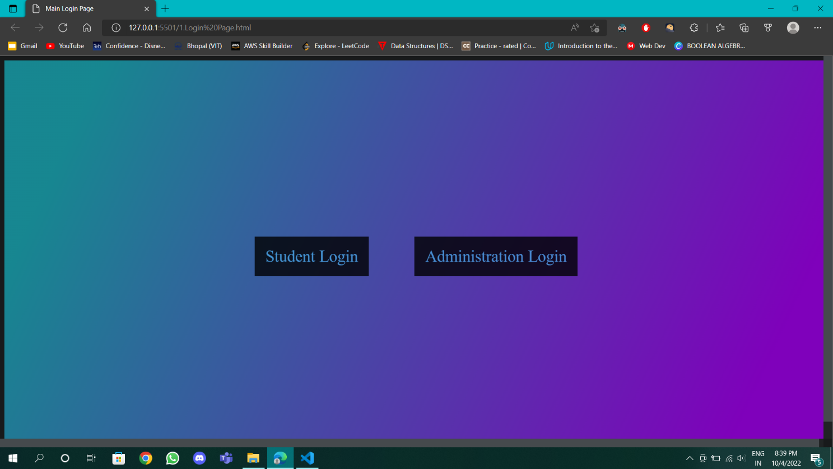

**ABSTRACT**

Basically this project is about the Student information system.

There will be 2 modules

1. ADMINISTRATIVE MODULE

Student info, hostel info, room info, mess info, health info, hostel employee, complaint, announcement.

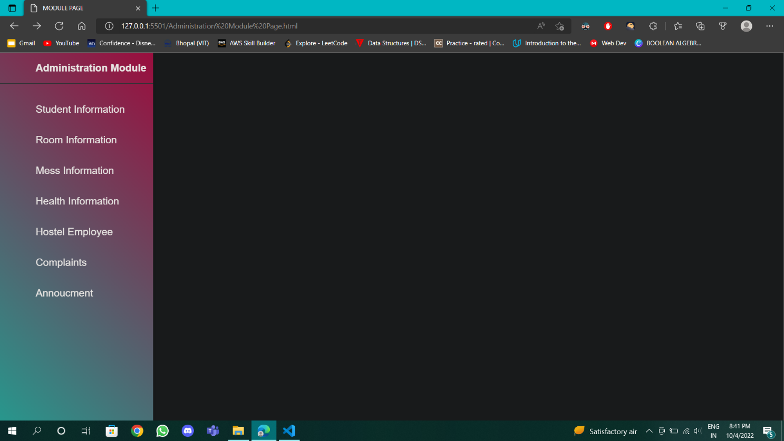

1. STUDENT MODULE

The following details may be asked by them

. Name

. Unique id

. Gender

. Age

. Address

. Parents info

ROOM CHANGING APPLICATION

The following documents are required

. Student name

. Registration number

. Current room no

OUTING APPLICATION

Same points are followed here and some points were added.

. Time he or she leaving

. Visiting address

. Parents info

COMPLAINTS

. It can be related to hostel, mess, medical etc.

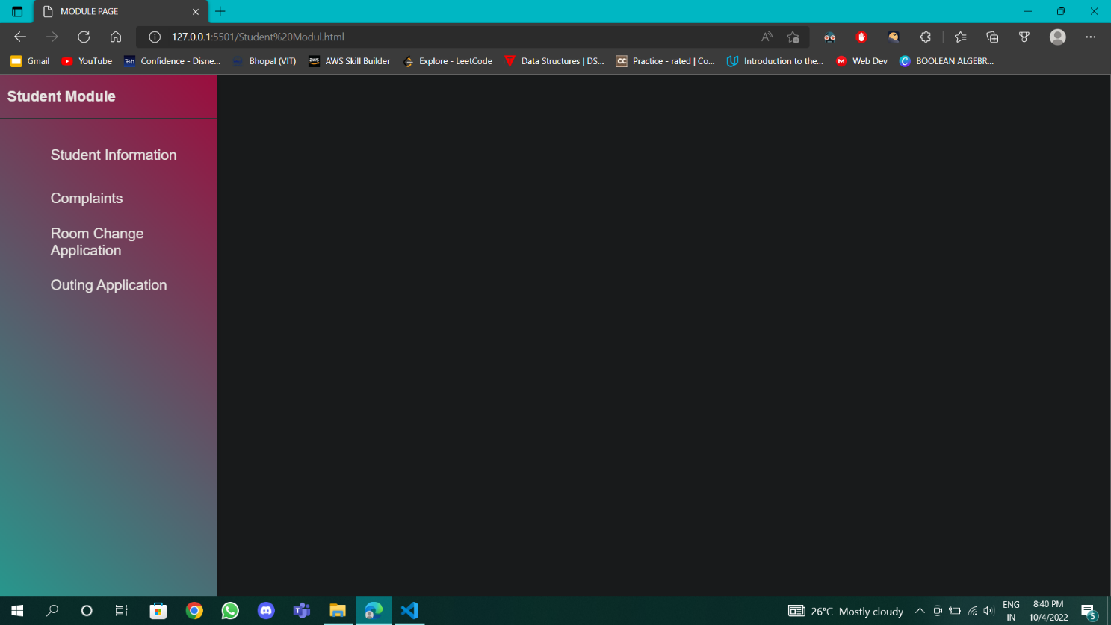

**TABLE OF CONTENTS**

|  |  |  |
| --- | --- | --- |
| **CHAPTER NO.** | **TITLE** | **PAGE NO.** |
|  | List of Figures  Abstract | 1  1 |
| 1 | **CHAPTER-1:**  **PROJECT DESCRIPTION AND OUTLINE** Introduction Problem Statement  Objective of the work | 3-4 |
| 2 | **CHAPTER-2:**  **RELATED WORK INVESTIGATION**  Core area of the project  Issues/observations from investigation  Summary | 3-4 |
| 3 | **CHAPTER-3:**  **REQUIREMENT ARTIFACTS**  Introduction  Hardware and Software requirements  Summary | 2-3 |
| 4 | **CHAPTER-4:**  **DESIGN METHODOLOGY AND ITS NOVELTY**  Methodology and goal  Functional modules design and analysis  Summary | 14-17 |
| 5 | **CHAPTER-5:**  **TECHNICAL IMPLEMENTATION & ANALYSIS**  Outline  Technical code  Prototype submission  Test and validation  Performance Analysis  Summary | 6-7 |
|  |  | 6- 7 |
| 6 | **CHAPTER-6**  **CONCLUSIONS AND RECOMMENDATION**  Outline  Limitation/Constraints of the System  Future Enhancements  Inference | 5-7 |
|  |  |  |

**CHAPTER-1:**

**PROJECT DESCRIPTION AND OUTLINE**

**INTRODUCTION**

As this project is mainly focused on the student information before entering into the hostel or in the campus the administrative person will ask you about the following details.

We need to Make students life simple by creating this system

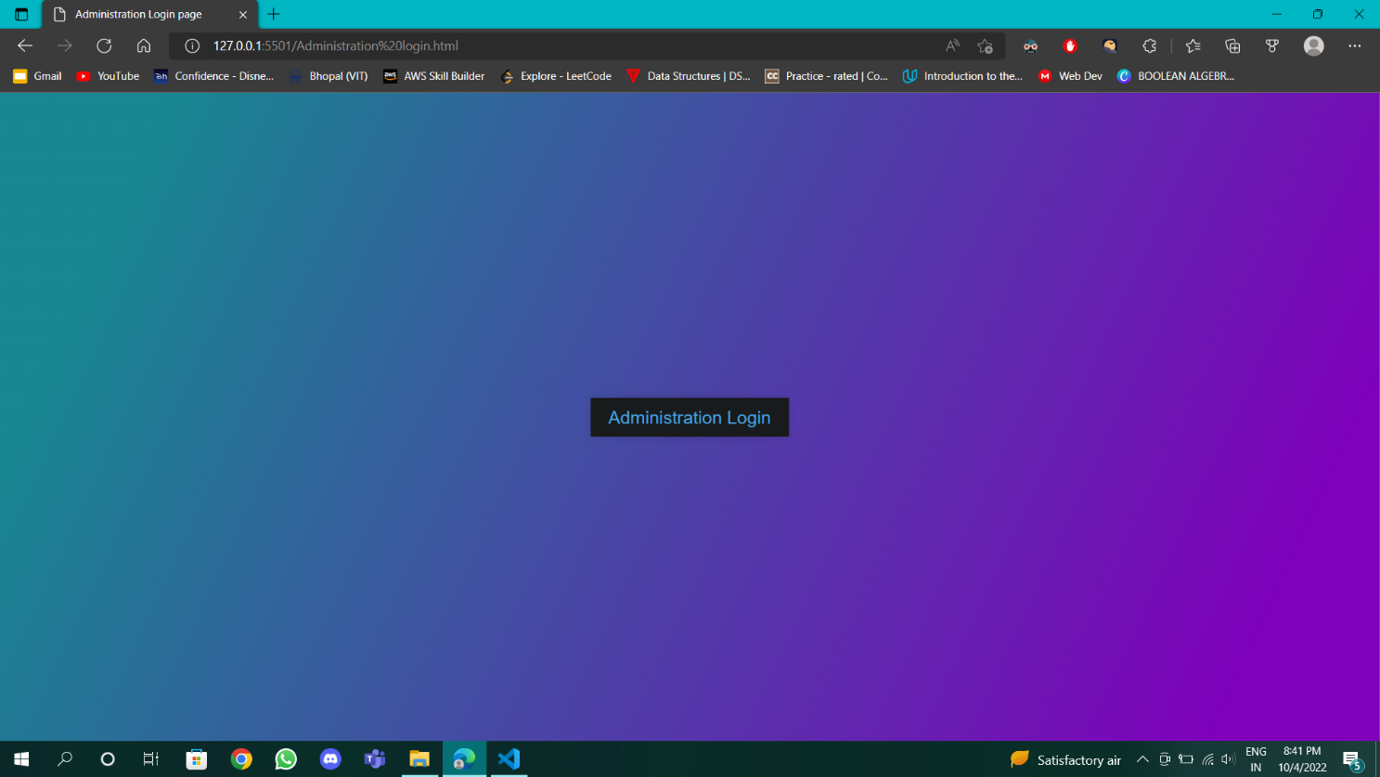

**PROBLEM STATEMENT**

We didn’t have any simple login system and Information system for students that’s why we make this project

**OBJECTIVE OF THE PROJECT**

* User Awareness

**CHAPTER-2:**

**RELATED WORK INVESTIGATION**

**CORE AREA OF THE PROJECT**

The core area of our project is the development of an website which provides complete information about students their issues in hostel.

**ISSUES/OBSERVATION FROM INVESTIGATION**

There are not Any website and system to manage college hostel issue faced by students . And most of the available Websites don’t have necessary features. This System is easy to use and with the help of this System the Students can and less difficulties in living in hostel.

**SUMMARY**

Our project is a one-step solution for all the needs of Students .With the help of our ideas, one can easily address there information.

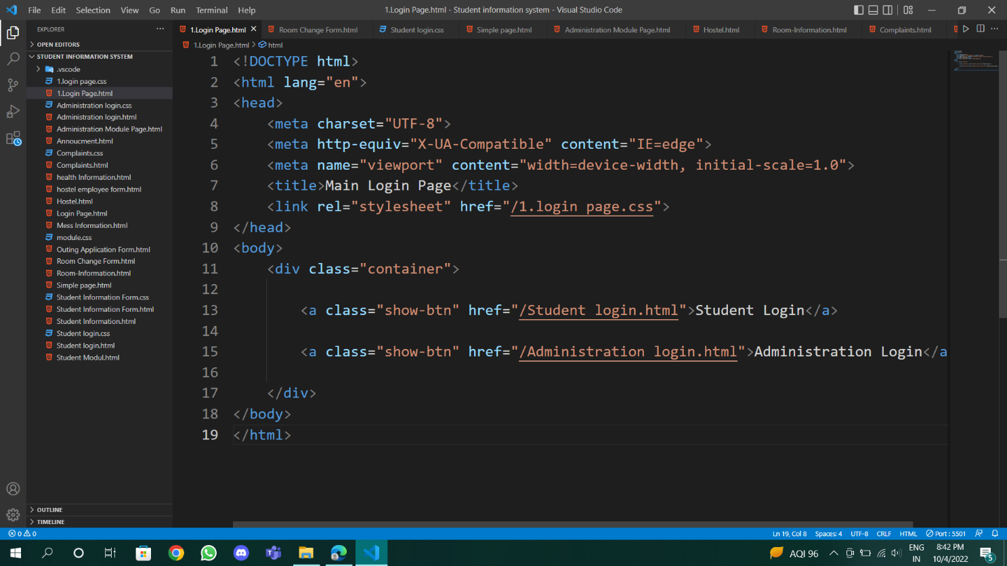

**CHAPTER-3:**

**REQUIREMENT ARTIFACTS**

**INTRODUCTION**

System requirements are the configuration that a system must have in order for a hardware or software application to run smoothly and efficiently

**HARDWARE AND SOFTWARE REQUIREMENT**

* 2GB Hard Disk Space
  + 1 Gb RAM min.
* 20GB Hard Disk Space
  + 8 GB RAM or more
* 1024 x 768 Screen Resolution
* VS code
* 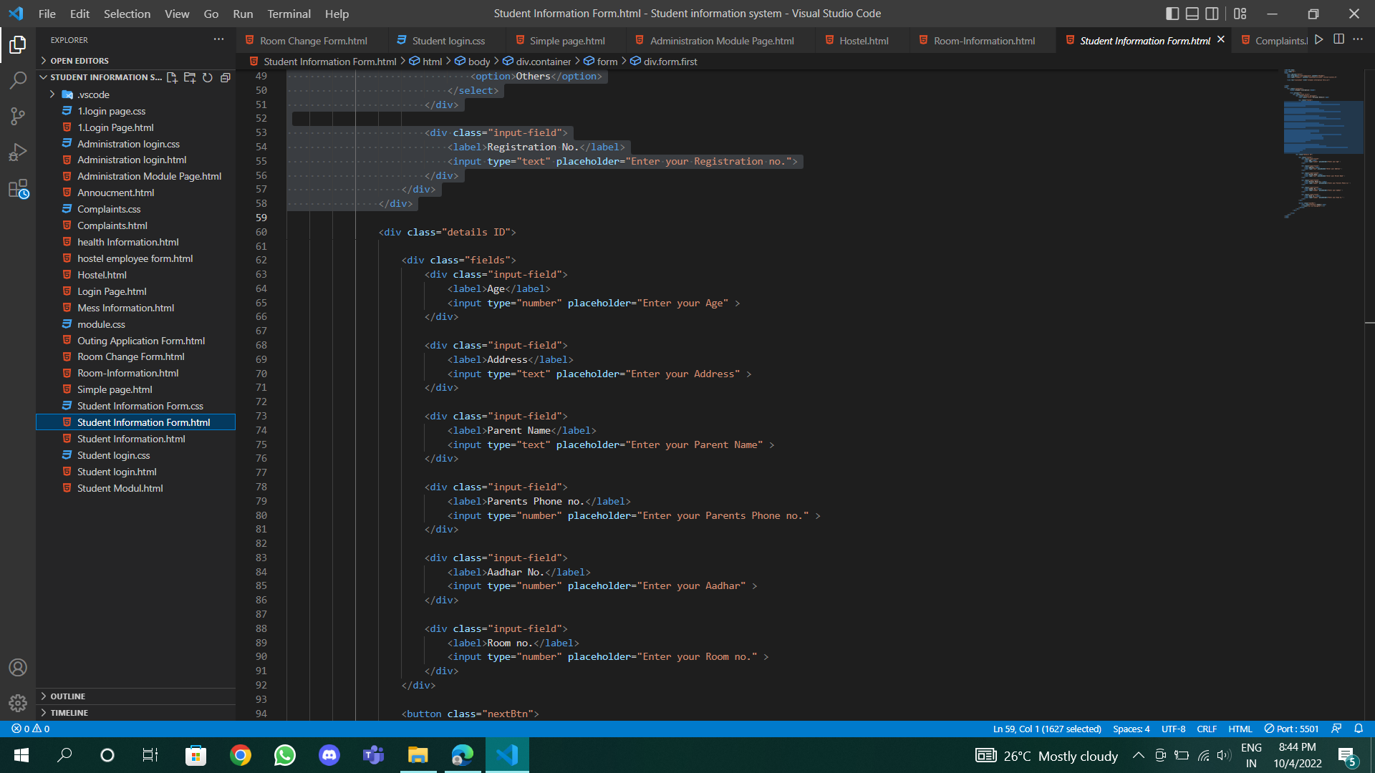

**SPECIFIC PROJECT REQUIREMENTS**

* Vs code
* Pycharm

**SUMMARY**

System requirements are the most effective way of meeting the user needs and reducing the cost of implementation. They are the first and foremost important part of any project, because if the system requirements are not fulfilled, then the project is not complete.

**CHAPTER-4:**

**DESIGN METHODOLOGY AND ITS NOVELTY**

**METHODOLOGY AND GOAL**

* Management of student information and Regulate it.
* Maintain a complete hostel info record, track the hygiene and share everything with your hostel needs.

**FUNCTIONAL MODULE DESIGN AND ANALYSIS**

* Student profile feature includes information about the particular student – student name , gender, unique Id , address , COVID certification,parents information, Aadhar card, room no of that particular student.
* Hostel info. – In this we are given the options with the types of room we want to accommodate like 2 bedded 3 or 4 etc.
* Room info – a particular student staying in a particular room
* Mess info –in this all the details of mess employee have been recorded and taken care of the mess menu and make sure that the Menu revised in every month.

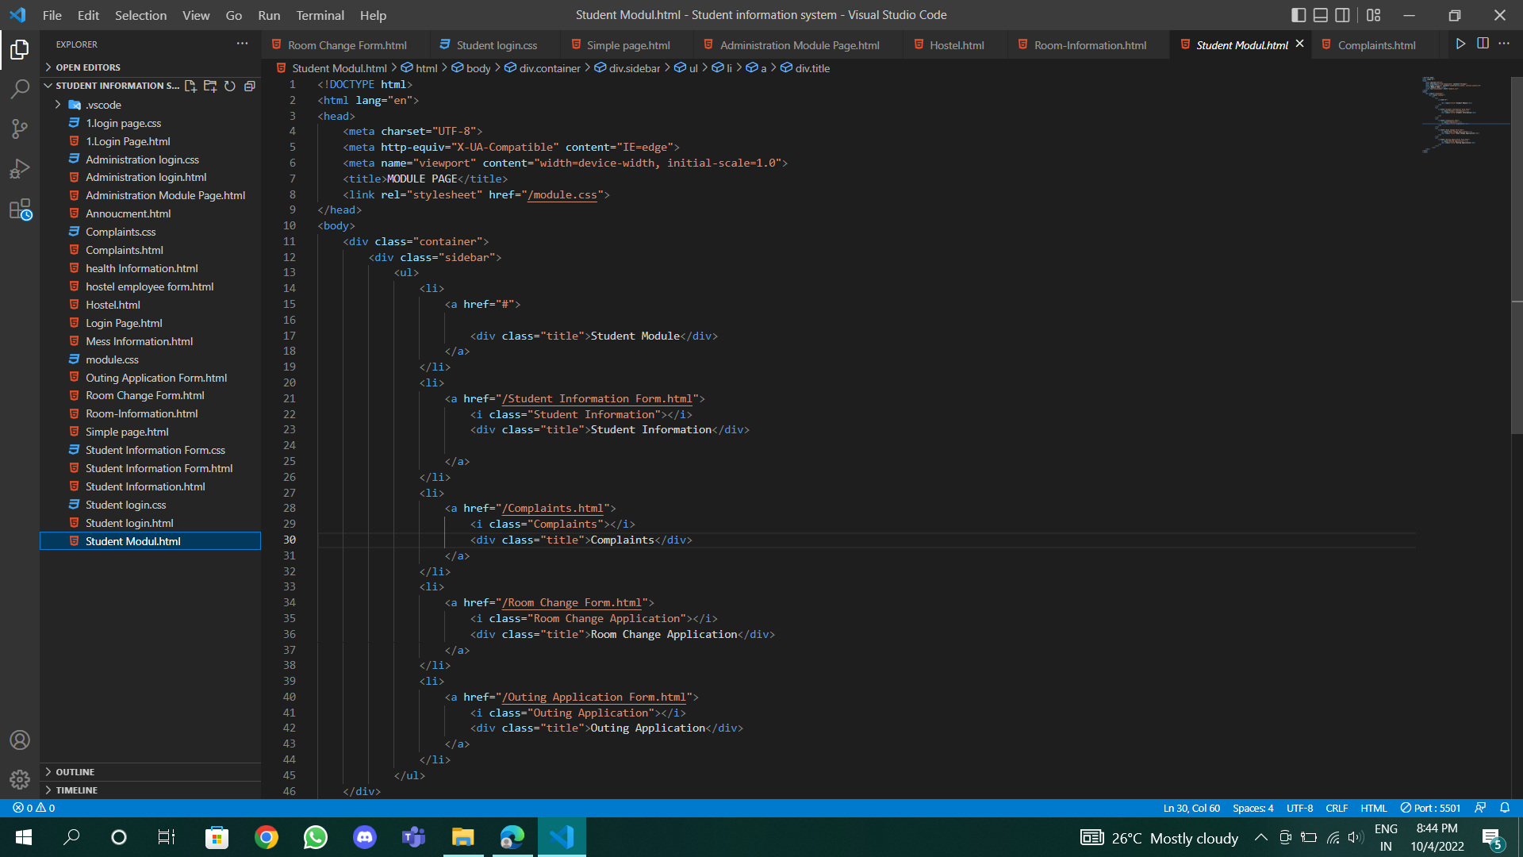

**SUMMARY**

This system is a single solution for all your needs and requirements in a hostel.

System requirements are the most effective way of meeting the user needs and reducing the cost of implementation. They are the first and foremost important part of any project, because if the system requirements are not fulfilled, then the project is not complete.

**CHAPTER-5:**

**TECHNICAL IMPLEMENTATION AND ANALYSIS**

**OUTLINE**

Technical Implementation and Design can be defined in a variety of ways based on the context and field of expertise. For our website, we will define it as such: The design, layout, deployment, fabrication, and implementation of interactive technologies and immersive designs into both new and pre-existing spaces.

**TECHNICAL CODE SNIPPETS**

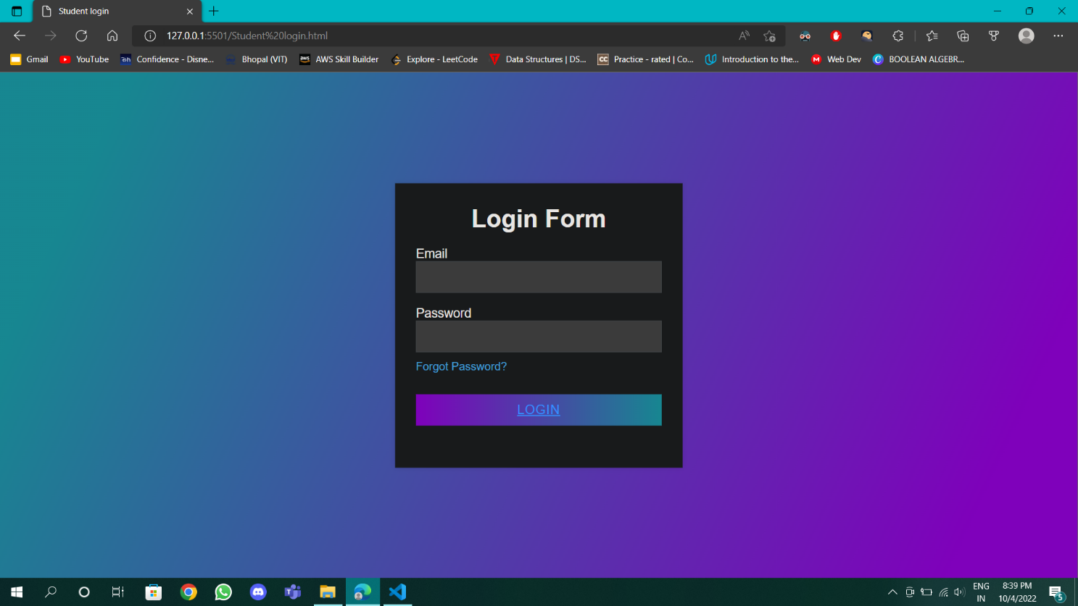

**PROTOTYPE SUBMISSION**

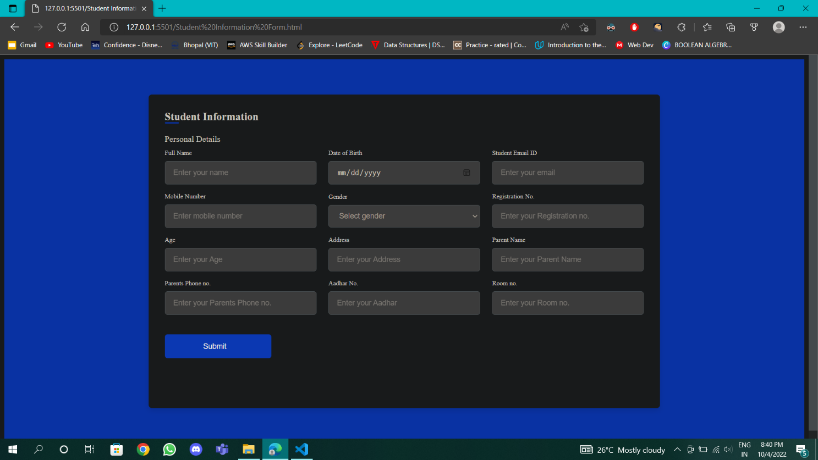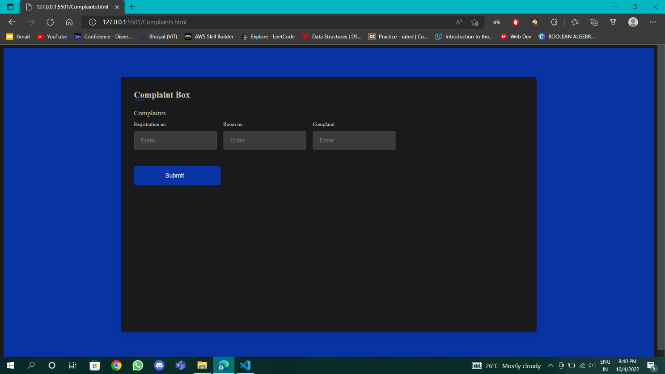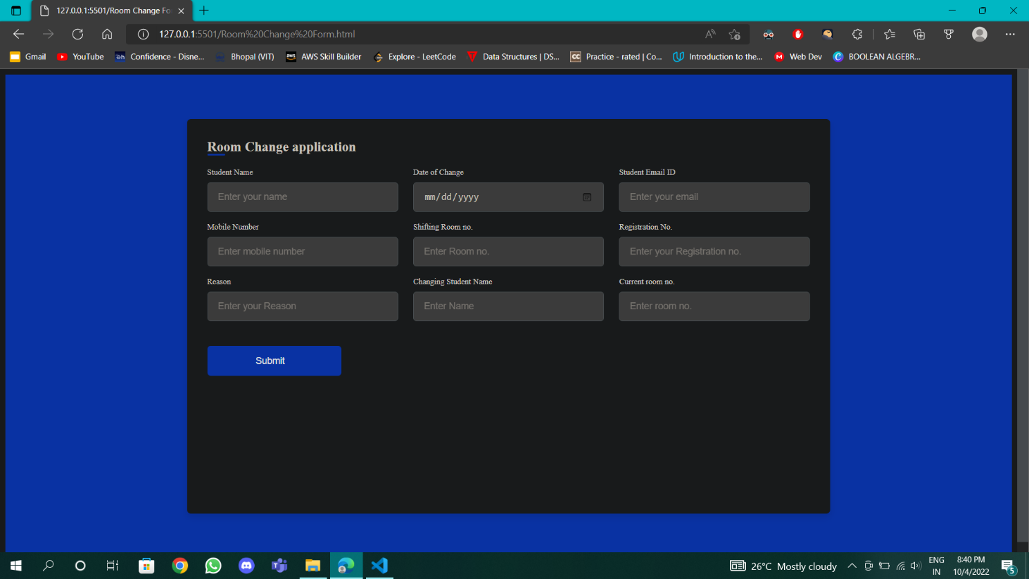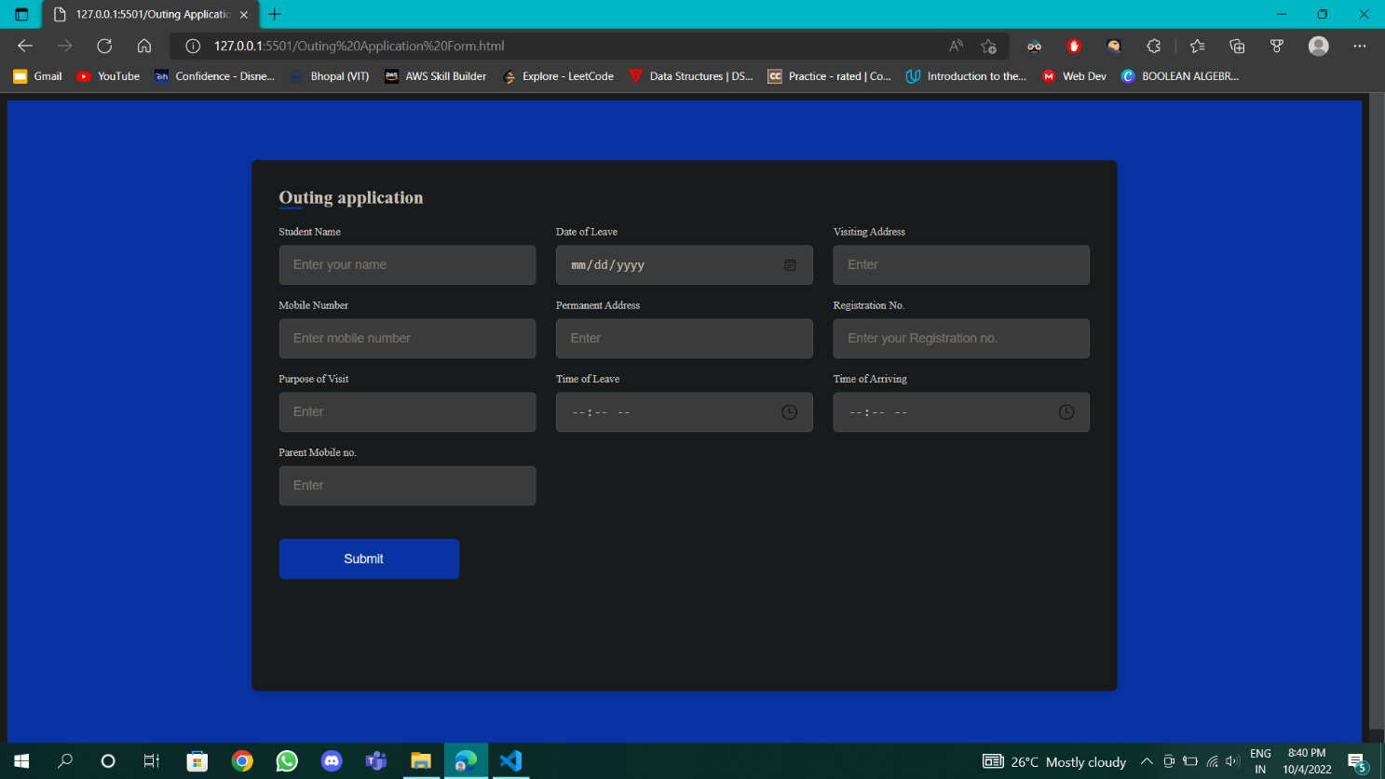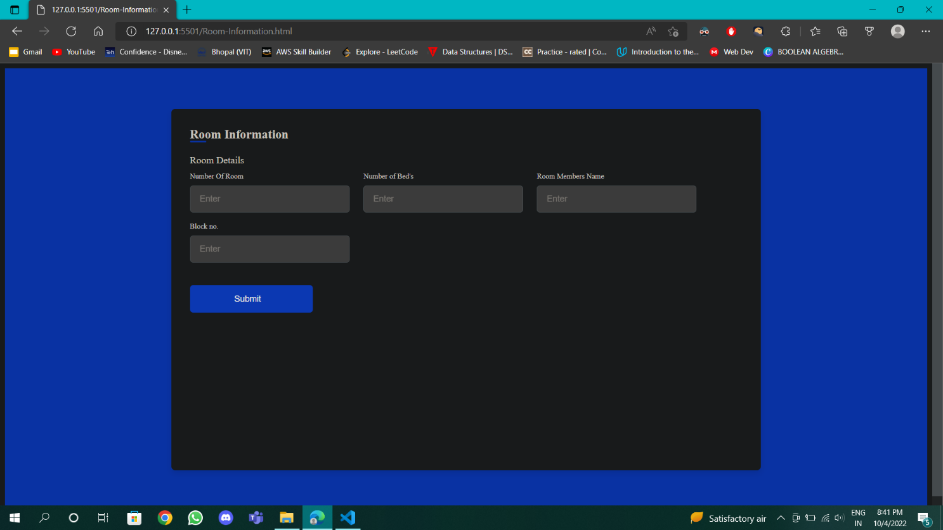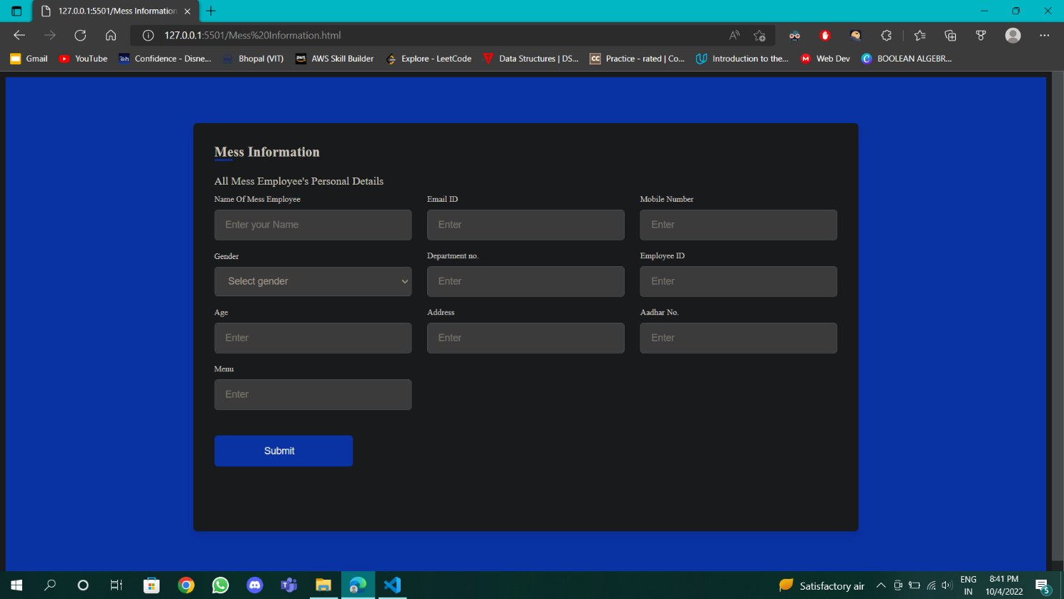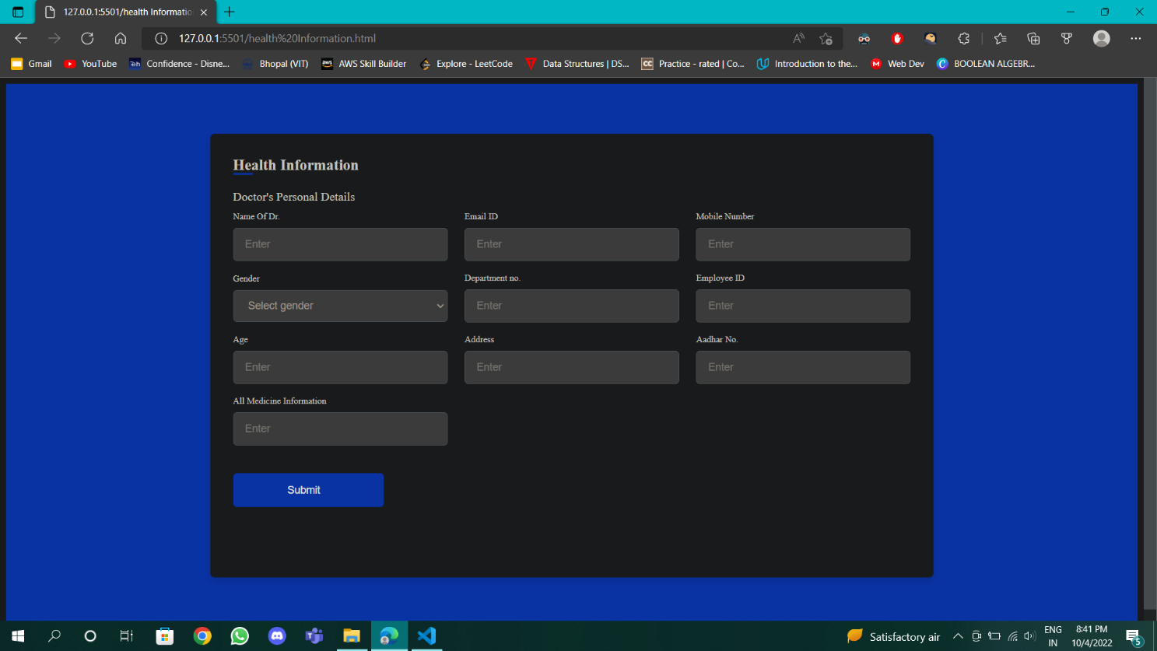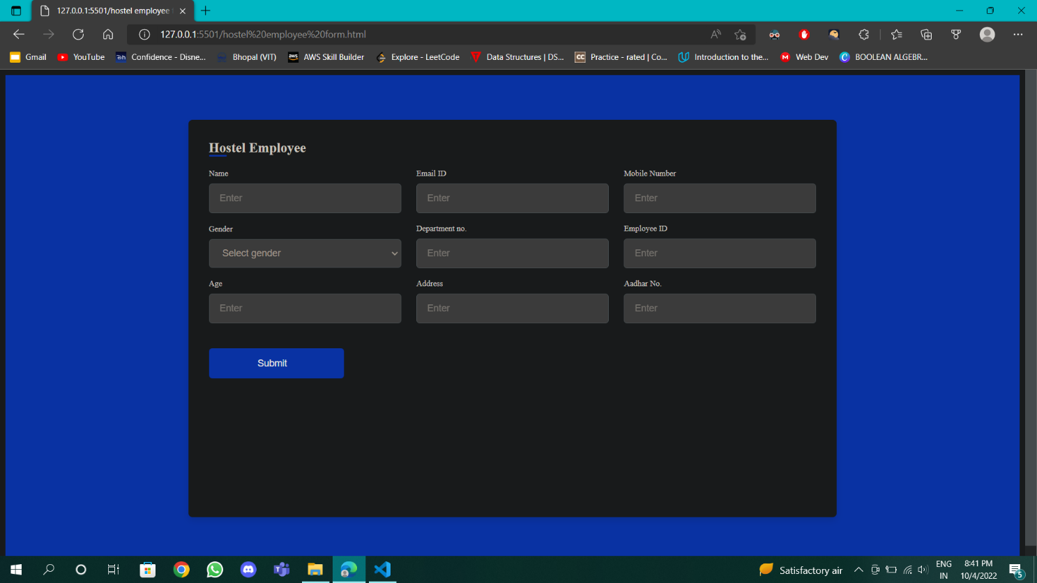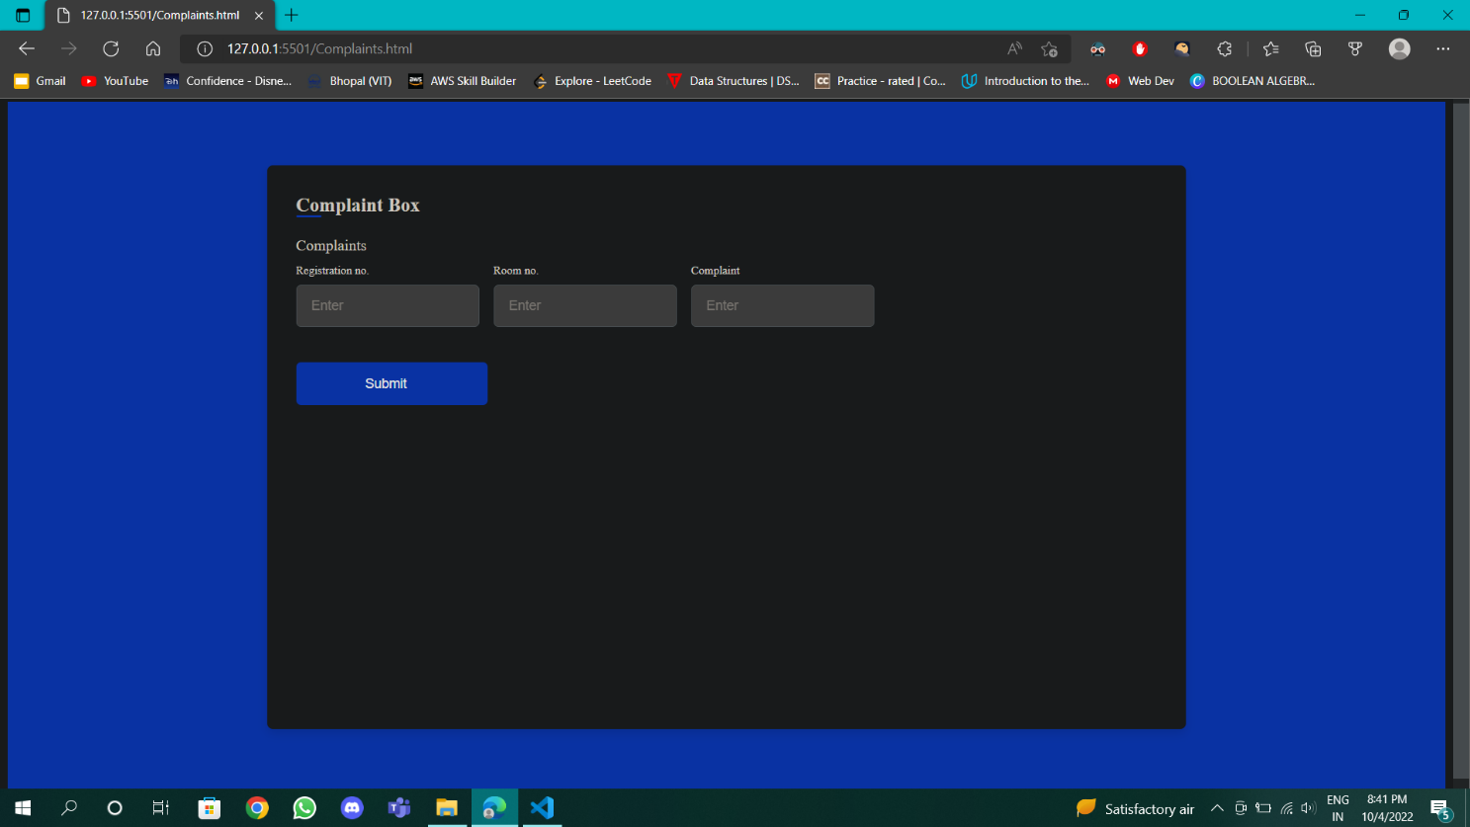

**TEST AND VALIDATION**

The website works well on any Sever Any administration can use with the features that are available on the Website.



**SUMMARY**

The Website is user friendly and eases the problems of hostellers.

**CHAPTER-6:**

**PROJECT OUTCOME AND APPLICABILITY**

**OUTLINE**

This Website also allows you to cheack medical history of all students .

**SIGNIFICANT PROJECT OUTCOMES**

Students applications helps the administration to know more about their students and how to deal with them.

**PROJECT APPLICABILITY ON REAL-WORLD APPLICATIONS**

Application includes a few things like the administrative can make a profile, choose their own roommates as well and rooms what they want 2 bedded, 3 or 4 bedded etc.

Collaborate with all the members of your organization using the Database.

**INFERENCE**

Student information systems that can give you every info. About the mess , Rooms, health info. , Announcement of any thing that is for the students. Room changing applications as before changing room some documents and a valid reason is required for it to give to the warden.

The following document are – Student name, registration no., Current room no, willingness, date of change, shifting room, valid reason.

**CHAPTER-7:**

**CONCLUSIONS AND RECOMMENDATIONS**

**OUTLINE**

This project is a single solution for all your needs and requirements in hostel. This includes complete medical records, outing history, Mess info, Doctorial info, complaint box is also there for the students and in that a dialogue box where administrative can view student complaints and update it or also forward it to the authority or that person.

**LIMITATION/CONSTRAINTS OF THE SYSTEM**

* One of the major limitations is the absence of proper information about hostel.
* The System only works for Hostellers.
* Real-time usage is limited.

**FUTURE ENHANCEMENTS**

* Its App version will be made available.
* Access to multiple Students profiles.
* Chat with different users of the app.

**INFERENCE**

Information about the student is more important .Our project makes it easier to know the info. In less timing as well.

information and work together in order to provide the best possible care.